# Solving Challenge 2: MailSploit

1. Run mailsploit.py from terminal / command line

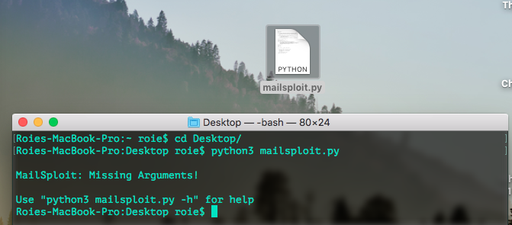

1. Alright, let’s try the help menu

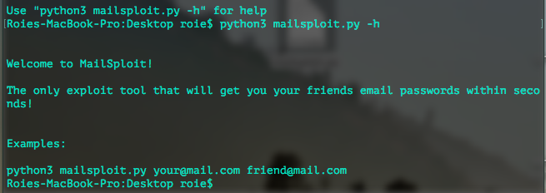

1. Run the exploit with valid mails

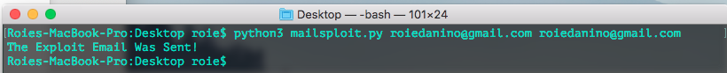

1. Check your mail box

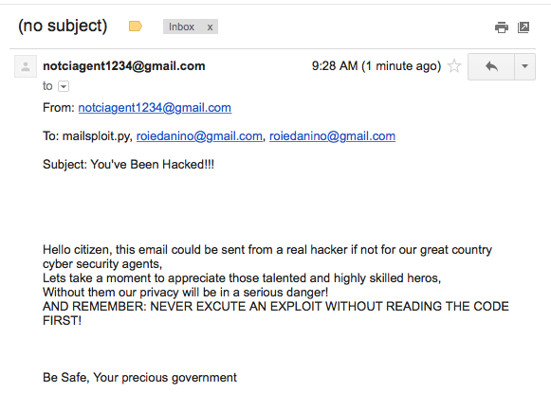

1. Read the code and find this agent Gmail Password

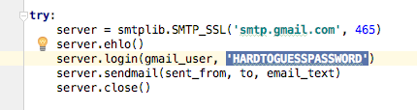

1. That was easy, right? Now let’s check his emails

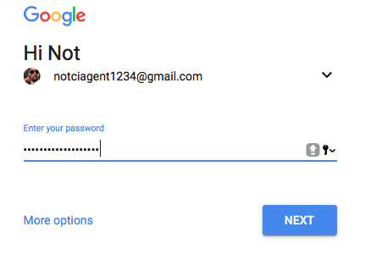

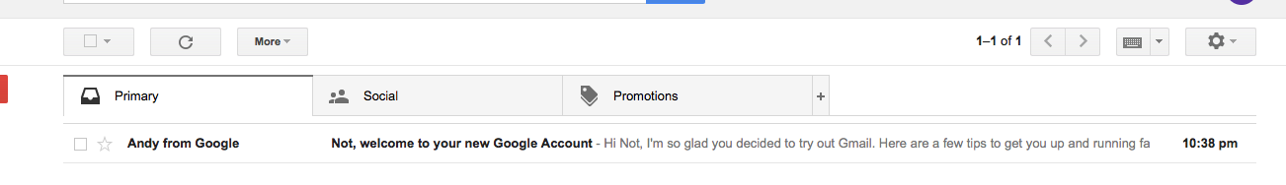

Nothing special so far

1. 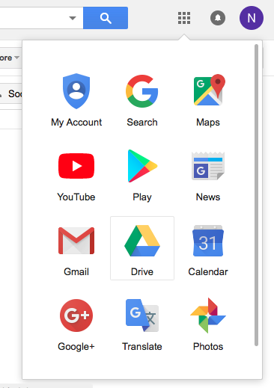Check his google drive

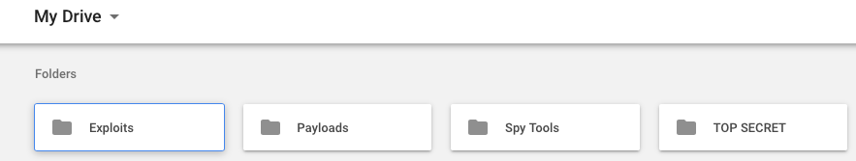

1. Open the TOP SECRET folder then open NO, SERIOUSLY, THIS IS CLASSIFIED!

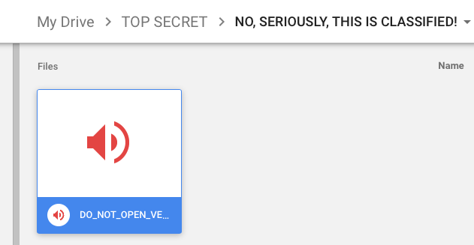

1. 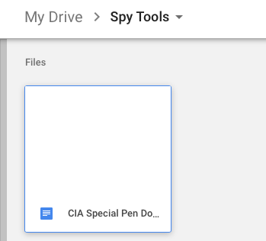The audio file sounds pretty weird, let’s look for possible tools, *Spy Tools* looks suspicious
2. Open the file and press ctrl A / cmd A

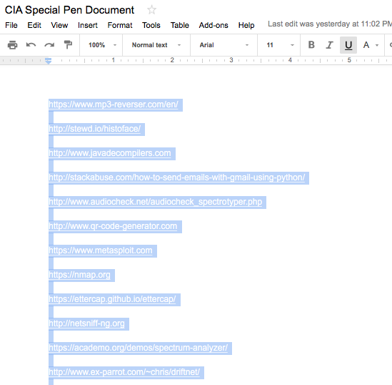

1. Notice that the only tools that accept audio as an input are:

1. <https://www.mp3-reverser.com/en/>

2. <https://academo.org/demos/spectrum-analyzer/>

1. Use the mp3 reverser tool to reverse the audio file

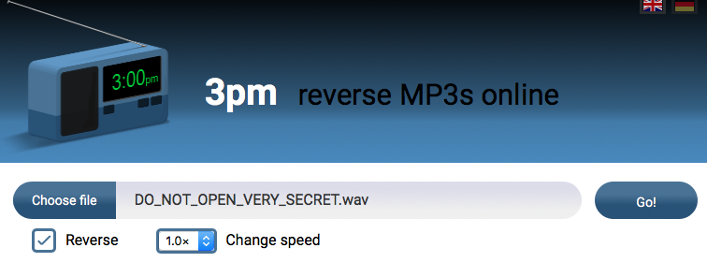

press Go! Then download the reversed audio file

1. Use the spectrum analyzer tool with the reversed audio file to see the flag

